Jiangxi Xirui Blade Manufacturing Co., Ltd.
竞品析报告

Double edge blade quality comparison test report
File name |  | Sample quantity: 3pcs each |  | Date： 2022年05月04日
Blade quality comparison test report |  | Material: Stainless steel |  | Lab Test Number：20220504002
Process flow
Double edge blades mainly go through five processes: stamping, heat treatment, grinding, chrome plating (carbon steel is not plated), and packaging;
Detailed comparison data
Item | 6cr13 Stainless Steel |  | Swedish Stainless Steel | Conclusion
Grinding process (detected under a microscope at 1600 times) | The grinding pattern can be seen as rough grinding, fine grinding and fine grinding. The lines are clear, the layers are distinct, and the cutting edge is smooth without gaps. |  | The grinding pattern can be seen as rough grinding, fine grinding and fine grinding. The lines are clear, the layers are distinct, and the cutting edge is smooth without gaps. | More comfortable to use without frustration
Blade Angle | Coarse grinding angle: 6°  Fine grinding: 10°  Fine grinding angle: 12° |  | Coarse grinding angle: 6°  Fine grinding: 10°  Fine grinding angle: 12.5°  (More comfortable) | The optimal angle of intersection between the blade and the skin is 24-26 degrees, corresponding to the fine grinding angle of the blade is 12-13 degrees, which is more comfortable to use.
Blade sharpness (life decay) | 11.8N/11.4N/10.6N/10.5N/10.6N/10.5N/10.01N/10.01N/9.9N/9.8N/9.7N |  | 10.1N/9.4N/9.4N/9.3N/9.1N/9.0N/9.0N/9.0N/8.9N/8.9N  （sharper and more durable） | The cutting resistance of the self-made double-edged blade is continuously tested and the cutting resistance is decreasing. The cutting sharpness of the product is stable at 10 knives, and the stability and life of the blade are higher.
Hardness | HRC:55.5 |  | HRC:56.3 | The blade has good physical properties and superior material properties
Chrome plating | The coating of the self-made double-edged blade is uniform, without interruption, and the surface of the blade is bright. |  | The coating of the double-edged blade is uniform, without interruption, and the surface of the blade is bright | The edge coating of the self-made double-edged blade is even and uninterrupted, which makes the edge stability and anti-rust ability more superior, and the service life and durability are stronger.
Blade compare | 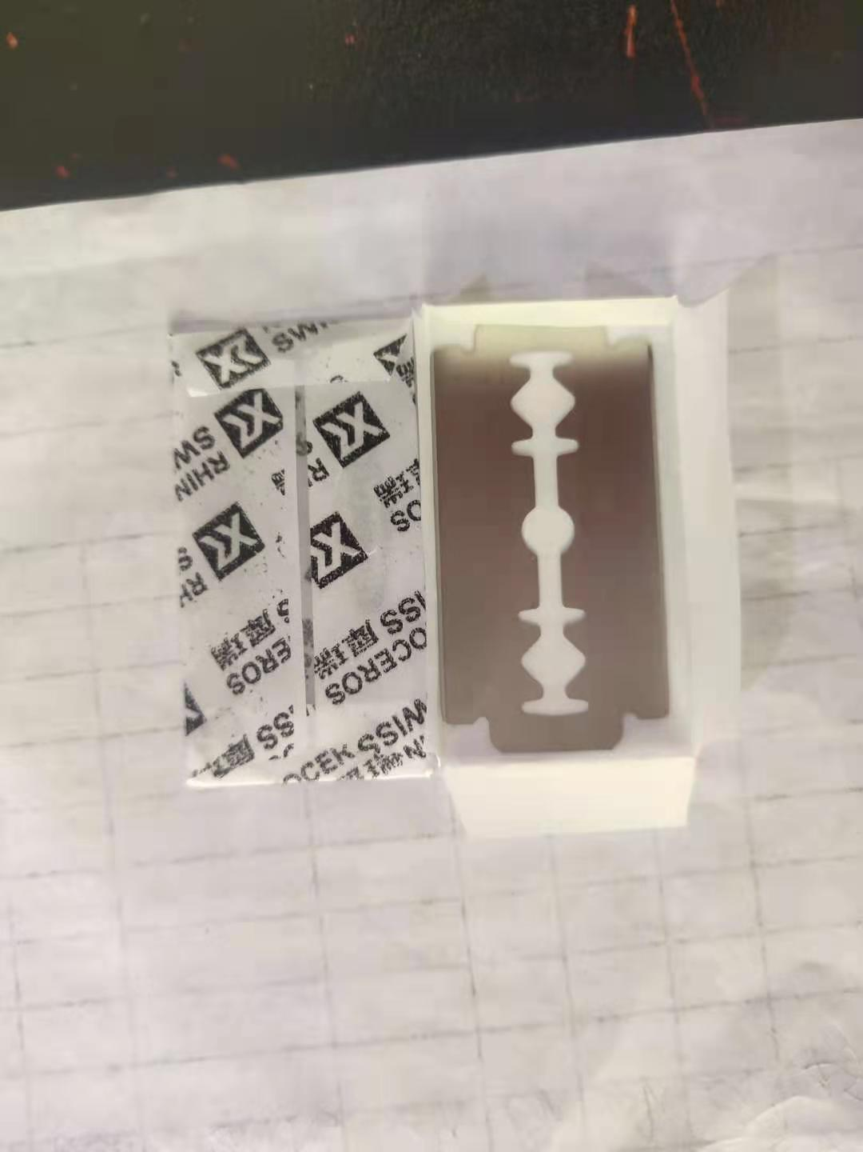 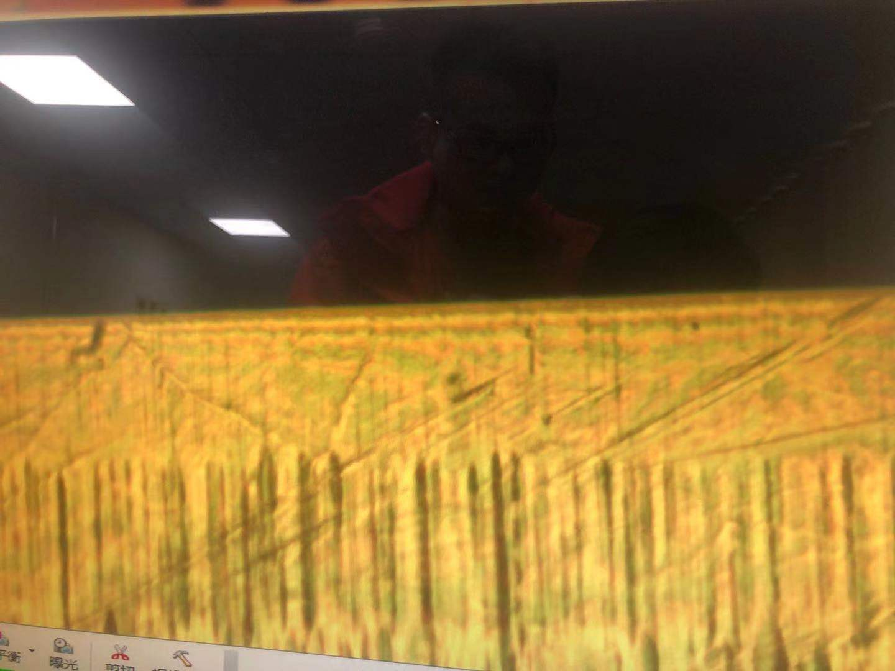（self-made）
Tester: Zhang Xiaozhen Reviewer: Lin Wei

